Colours
Background colour Code - #112231
Visual Background colour Code – #17293A
Visual Border Round - 10 & Visual Border Round Color Code - #17293A
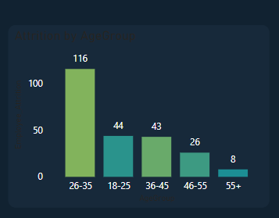
KPI Cards Colour Codes :-
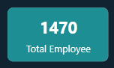 #1C8E94 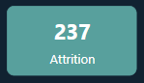 #58A09D
 #55A5AB 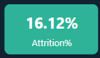 #2EB398
 #82B35C 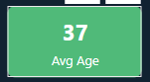 #50BA79

Default Colour Code - #30475D  Transparent 70%
Selected Colour Code - #82B35C 

Measures

Employee_Count = DISTINCTCOUNT(HR_Analytics[EmpID])


Employee_Attrition = CALCULATE([Employee_Count],HR_Analytics[Attrition]="Yes")


Avg_Years_atCompany = AVERAGE(HR_Analytics[YearsAtCompany])

Years_With_Text = ROUND([Avg_Years_atCompany],0)&" Years"


Attrition% = [Employee_Attrition]/[Employee_Count]


Avg_Salary = AVERAGE(HR_Analytics[MonthlyIncome])


Avg_Age = AVERAGE(HR_Analytics[Age])

